Spring boot: amazing framework that gives you everything you need to build application, logging, security, connecting to data base, configuration, …(module)

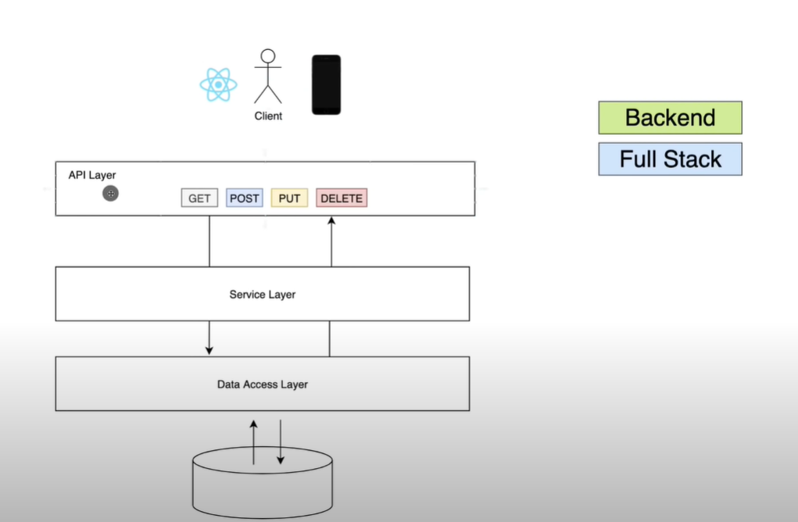

Crtl+N = generate

@RequestMapping(path = "api/v1/student")

Instead of localhost:8080 we will have localhost:8080/api/vi/student

Service layer responsible for business logics

@autowired :the framework introduced annotations-driven Dependency Injection. The main annotation of this feature is @Autowired. It **allows Spring to resolve and inject collaborating beans into our bean**.

@Component is a class-level annotation. It is used **to denote a class as a Component**. We can use @Component across the application to mark the beans as Spring's managed components.

In Spring, **the objects that form the backbone of your application and that are managed by the Spring IoC container** are called beans. A bean is an object that is instantiated, assembled, and otherwise managed by a Spring IoC container. Otherwise, a bean is simply one of many objects in your application.

Spring IoC Container is **the core of Spring Framework**. It creates the objects, configures and assembles their dependencies, manages their entire life cycle. The Container uses Dependency Injection(DI) to manage the components that make up the application.